PUMA with FreeEMS vanilla firmware assembly and installation Manual

(insert PUMA eyes here)

TOC
- Overview. PG 2
- Getting the hardware. PG 3
- So you have a bare board, now what? PG ?
- You now have a board with components, now what? PG ?
  - Testing your board with Jim Stim. PG ?
  - Uploading the initial firmware. PG ?
- Connecting the board to a vehicle. PG ?
- Uploading firmware via USB and boot loader. PG ?
- Tuning your engine. PG ?

Appendix I. Spin1 specific notes. PG ?
Overview.

Puma uses FreeEMS vanilla firmware, PC tuning software and PUMA hardware to control fuel and ignition of large variety of engine configurations. See http://puma.freeems.org for a more detailed overview of what PUMA can do and is used for.

We recommend you purchase the hardware such that many of the below steps aren't required. This version of the manual includes instructions for the Spin 1 board, which was generally provided as just a bare board. You will need to purchase parts based on a BOM then install those parts. You will also need to program the board via BDM programming port to get the initial bootloader installed. After the initial build, you will be able to program the board with an USB cable and a standard PC.

Note these sections are written as modules, such that sections are useful on their own, but also arranged in a sequence that is handy for a first time installer.
Getting the hardware.

The design and software is OpenSource and while you can technically build it by yourself, we recommend you purchase PUMA assembled. This is how you get the hardware, blah blah blah.

Spin 1 offered just the bare board, so there are notes about how to do some low level assembly, but future spins will likely remove these assembly notes.
So you have a bare board, now what?

Ok, you have the bare PCB, and it's going to need components installed on it to function as a EMS. This is what you need to do:

These first couple steps are in no particular order.

1. Get the BOM from site, its in csv format, so you can select what modules you want populated.
A few things to note:
- EGT circuit won't work, it has a 500°C limit.
- The usb connector is plain wrong. In the BOM you can choose to buy a cable to use this wrong (female-A) connector, or buy another usb connector and hack things to install it.
- You don't want the shutdown circuit, so its FETs aren't in the BOM. Don't worry about that.

Once you are decided about the BOM, go to to digikey and place the order.

2. modify the board as shown in “Spin 1 specific notes”

We recommend doing these steps sequentially.

- Install MCU and critical components.
- Test the MCU works by uploading the firmware
- install rpm input circuit choose hall input, or VR
- install misc outputs like Fuel, ect
- install injectors circuits
- install ignitions circuits
You now have a PUMA board with components, now what?

You will likely want to verify the board is good with a Jim Stim then it will need the initial firmware installed. If PUMA was purchased assembled, these steps should not be required, and you can proceed to the next step.

Testing your board with Jim Stim.

Blah blah blah, fill in this stuff.

Uploading the initial firmware.

BDM loader notes and more blah blah blah.
Connecting the board to a vehicle.

General notes about connecting it to a motor.
Uploading firmware via USB and boot loader.

So you have a PUMA that may or may not be connected to your system. This is how to upload a new firmware file to that board.

Download and install ???
Open ???
Configure USB/232 port
Specify to upload firmware file.
Tuning your engine.

If you have engine setup blah, this is the basic way to tune your engine.

If you have engine setup blah2, this is the way you tune your engine.
Spin1 specific notes.

- This spin has several modifications. Start these modifications by cut the wrong traces, and adding jumpers as shown below.
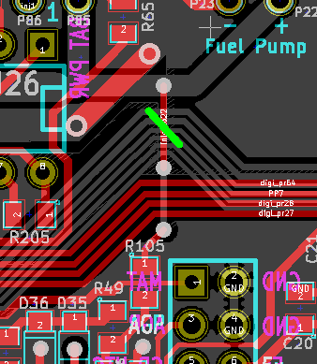Illustration 2: Change vBat reference source
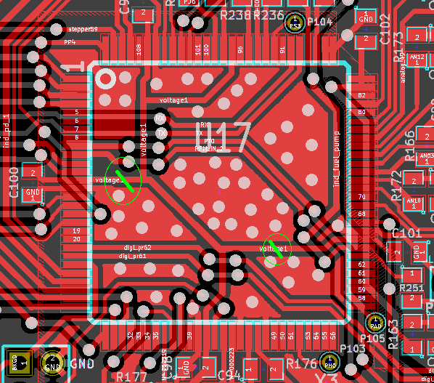Illustration 1: There are wrong MCU VDD traces

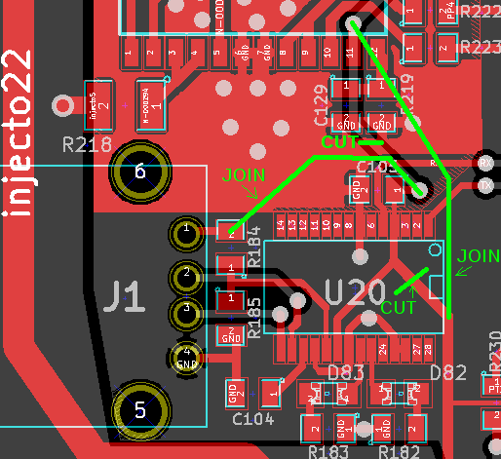Illustration 3: This supplies the FT232 from the PC instead of the internal reg

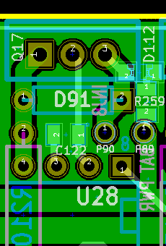Illustration 4: In case you use the peak&hold setup

- You have the PCB + components, so get KICAD and the files, or the pdf files from puma.freeems.org. PDFs aren't search-able so you may want to choose to install KICAD until we workout that.

- Start the assembly!

Just solder the components. If you ordered a board, you should know how to do it. An oven is a fast way to get it done.

Don't put too much paste for the small regulator, or it will get misaligned.

Components that shouldn't be populated:
- F1, F3 (Fuses)
- R226, R227, Q18, Q19, bridge pin 1 and 3 of Q19 (this is the shutdown circuit)
- R133 (bad pullup)
- R228 OR R229, using one of them defines whether the XOR negates or not its outputs.
- If you use VR inputs, R212, R213, R215, and R216 should be bigger, like ¼ or ½W. 10Kohm to 20 kohm will be fine.
- U18, R186, R187, C107, D74, D75, C106 (thermocouple driver)

5. Program the MCU using a BDM pod.

Install Codewarrior, open the programmer, go to File-> Load application, and select the .s12 (FreeEMS serial monitor).

It should get connected, program it, verify, and never complain.

6. Load FreeEMS firmware, using seank's loader.

7. Install MTX and connect to the board to the PC to check that freeems is running.

